**Data Structures and Algorithms**

**Lab Report**

**Lab02**



|  |  |
| --- | --- |
| Group Members Name & Reg #: | **Muhammad Haris Irfan**  **(FA18-BCE-090)** |
|  |  |
| Class | Data Structures and Algorithms CSC211 (**BCE-3B**) |
| Instructor’s Name | Dilshad Sabir |

**In Lab Tasks**

**Question no: 1**

Enter a New Node to the list and print it.

**Solution:**

The Result of the following code is attached below:

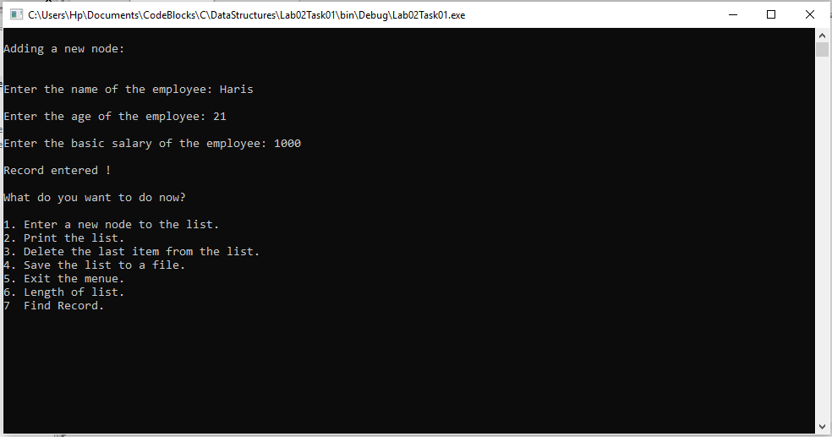

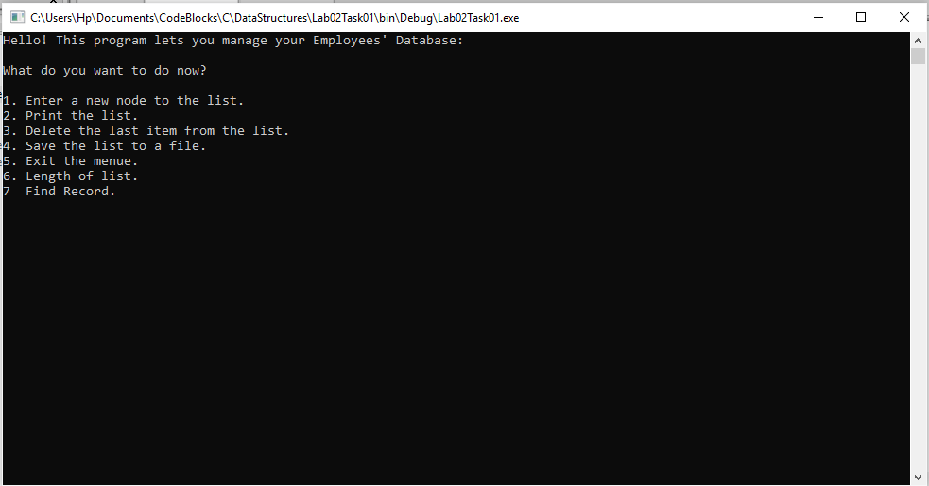

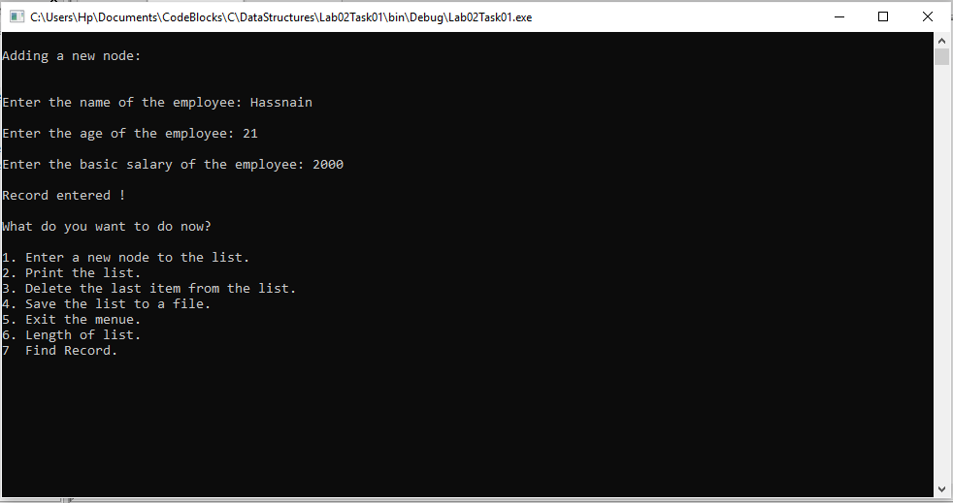

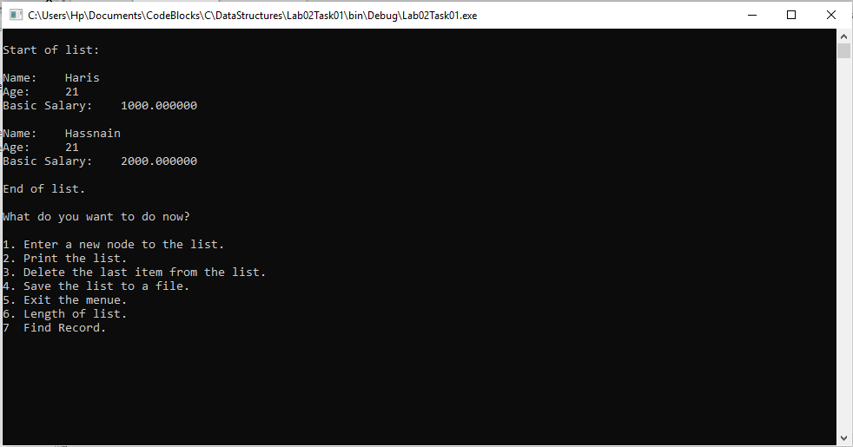

In this task I added two new nodes, and printed their data successfully.

-------------------------------

**Question no:2**

Write a code to display the length of list.

Solution

The code is shown below for the given program and its results are given below,

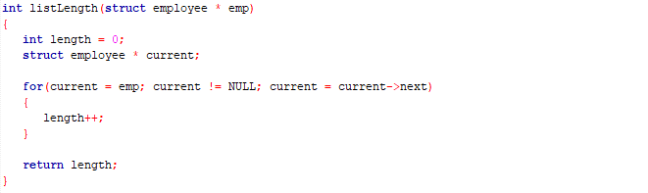

The Result of the following code is attached below:

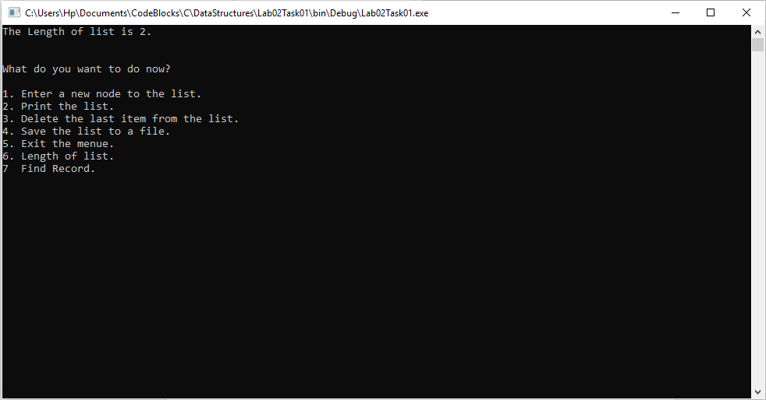

As we have only entered 2 nodes, the length is 2.

------------------------------

**Question no:3**

Write a code to Find Record by age from the Database.

Solution

The code is shown below for the given program and its results are given below,

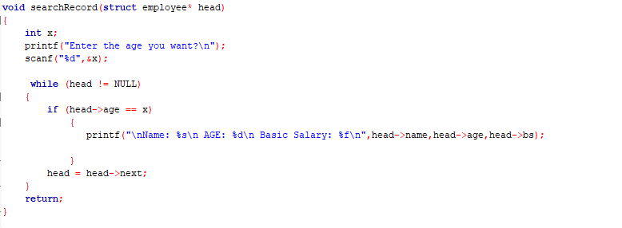

The Result of the following code is attached below:

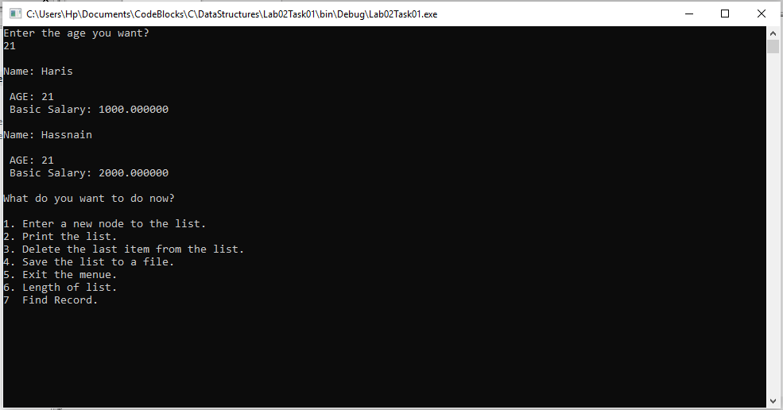

------------------------------

**POST LAB**

**Question no:4**

Write a code to Delete the Last node from the Database.

Solution

The code is shown below for the given program and its results are given below,

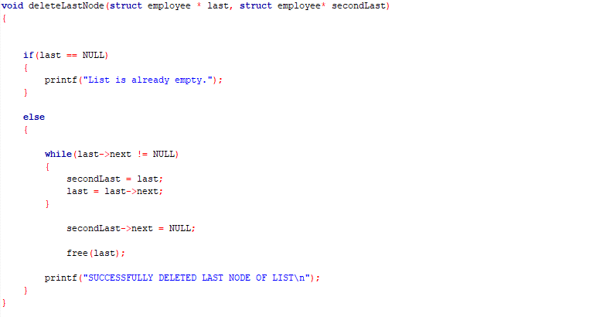

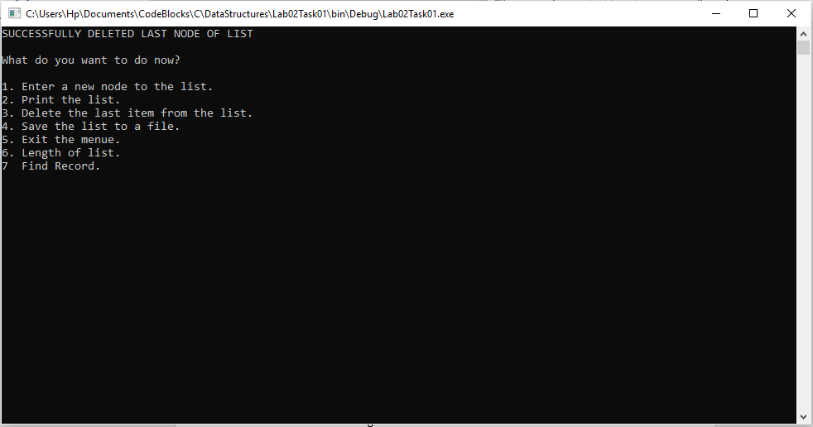The Result of the following code is attached below:

After deleting the last node successfully, we printed the list to check if the last node was deleted or not.

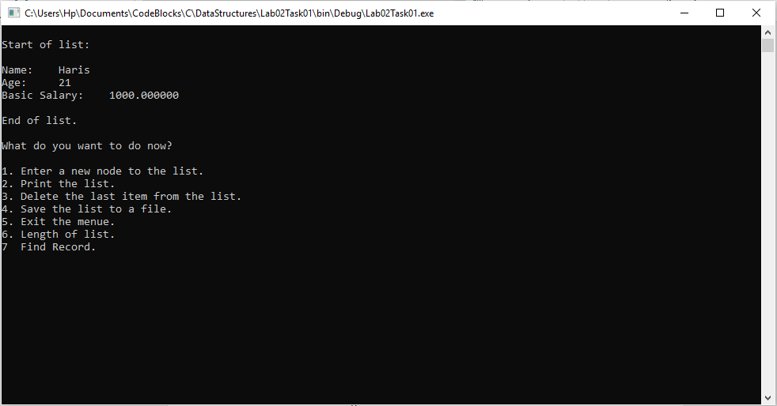

Hence, our code works fine as our last node is no longer present.

------------------------------

THE END